**P33 Final Project Submission**

Figma Mockup

* [Mockup Link](https://www.figma.com/file/QT4CAciE8GnJ2yyDTJZLXS/P33-Website-Design?node-id=830%3A14182&t=yvPRyaKpu4gy3geD-1) (Same as Mockup Images below)

Presentation Slides

* [Presentation](https://docs.google.com/presentation/d/1kmWzLu-rjwCD-Yj2FcG7nJRk1WAkROkRgiZHVaX8gNY/edit?usp=sharing)

**Mockup Images Below**

Landing Page

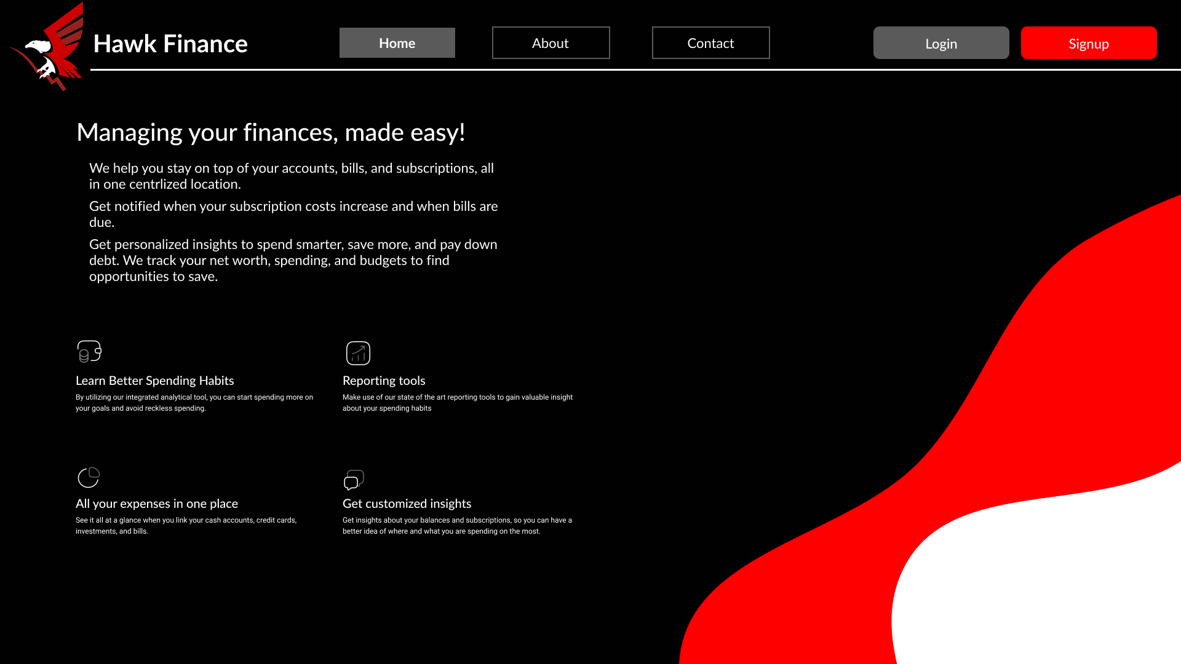

About Us Page

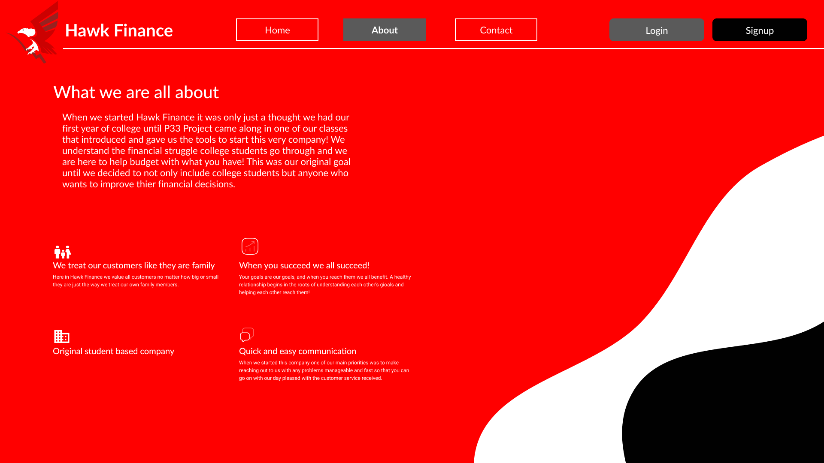

Contacts Page

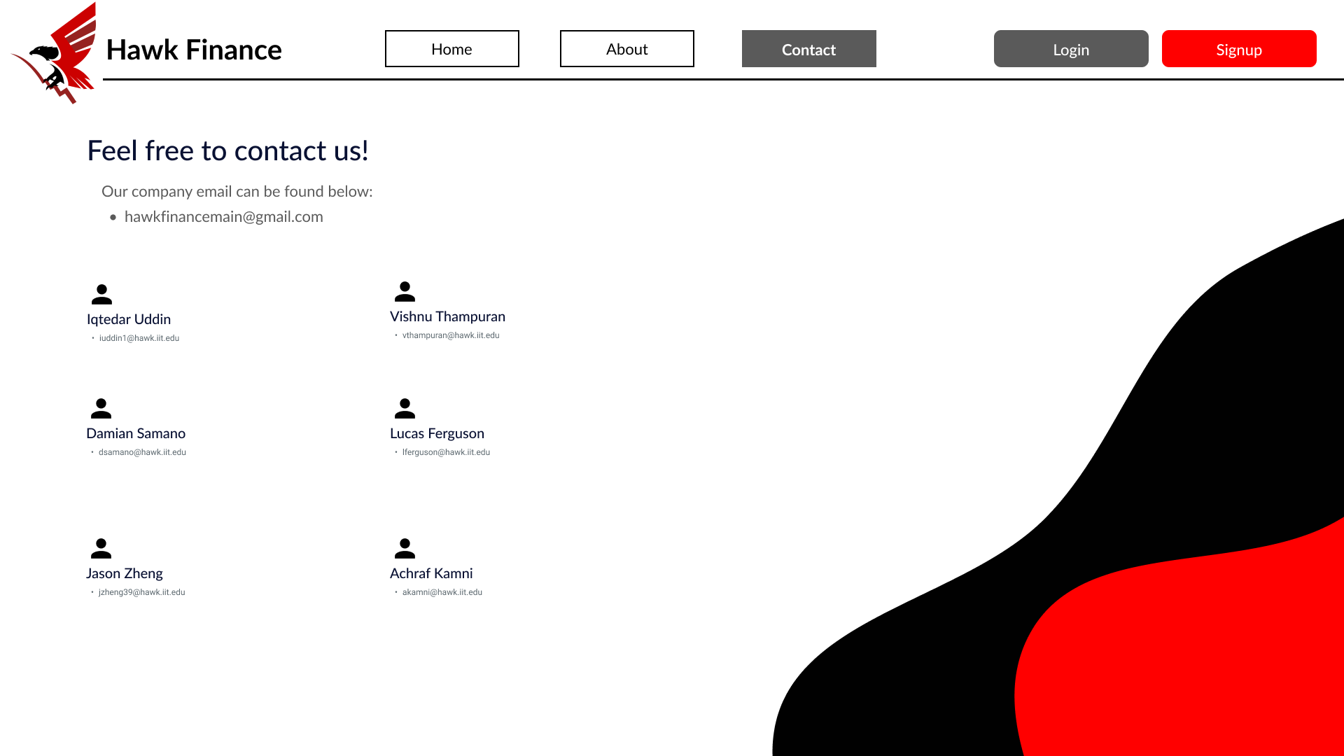

Dashboard

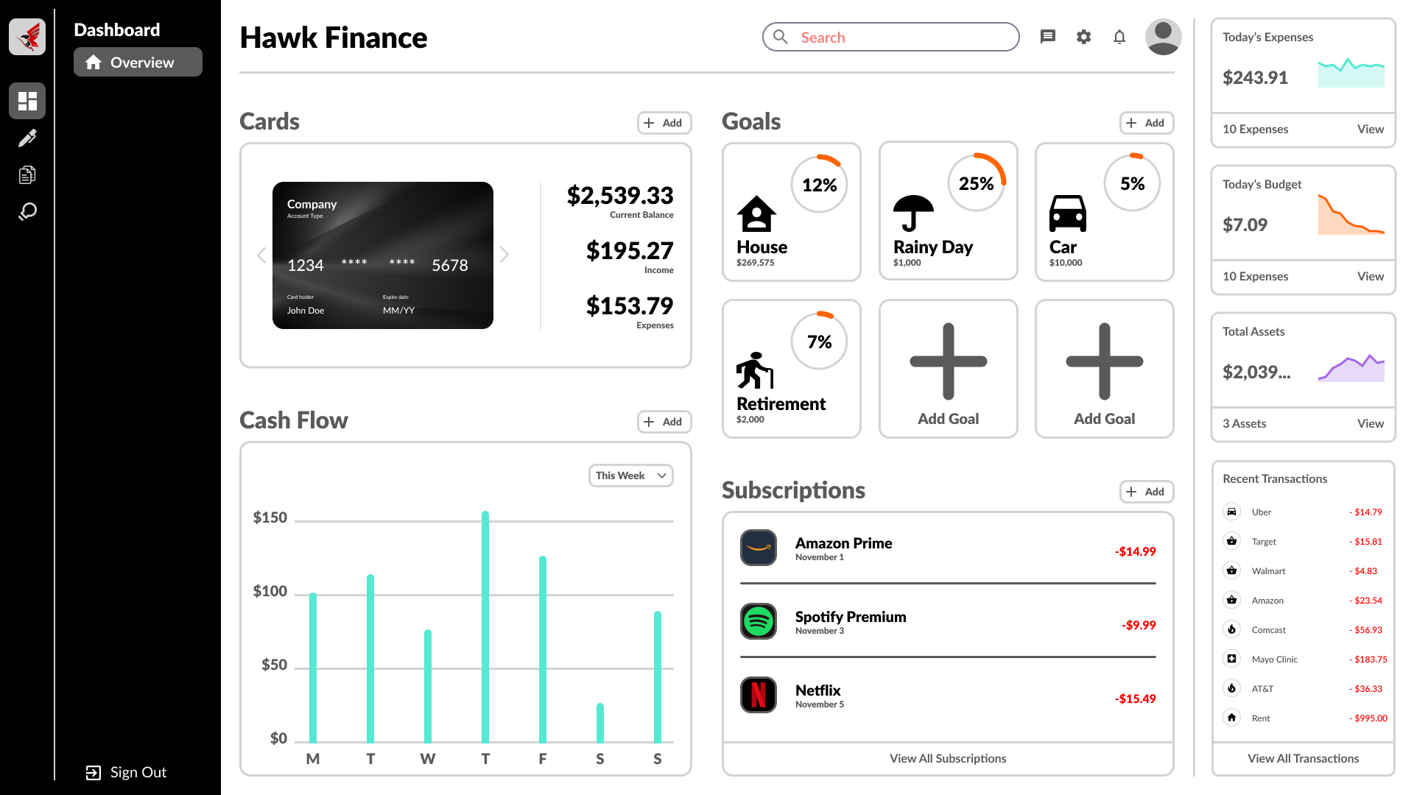

Inputting Cashflow

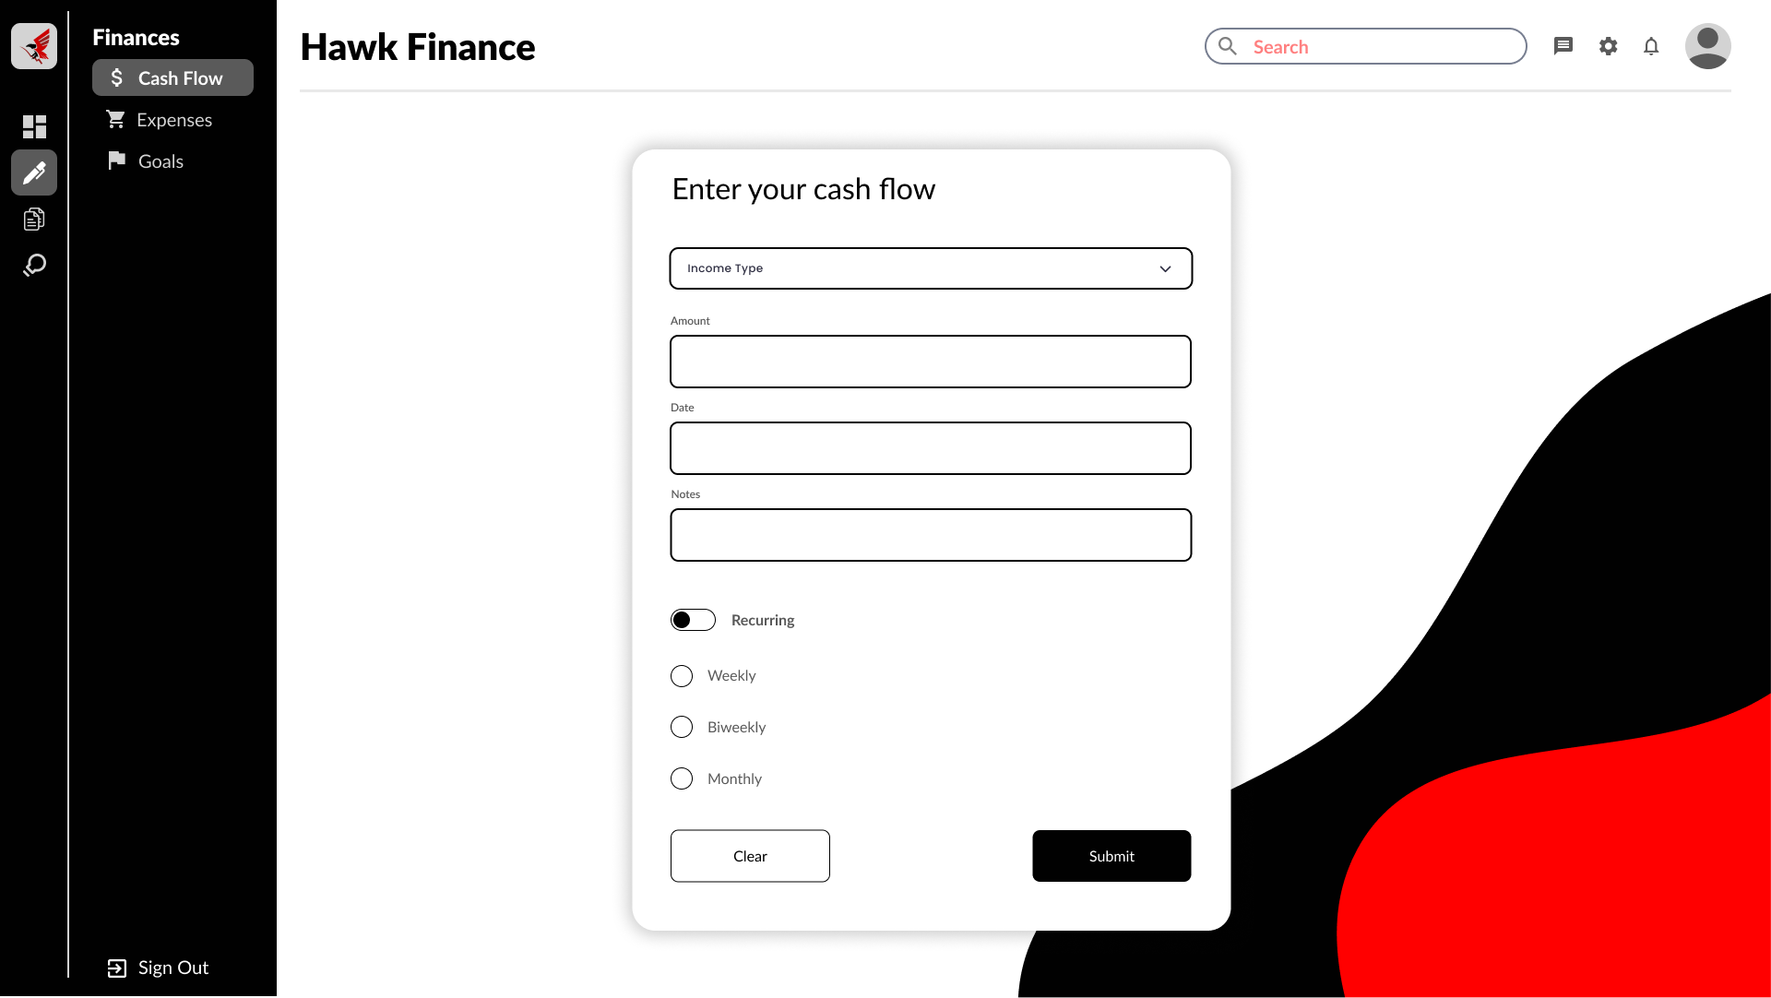

Inputting Expenses

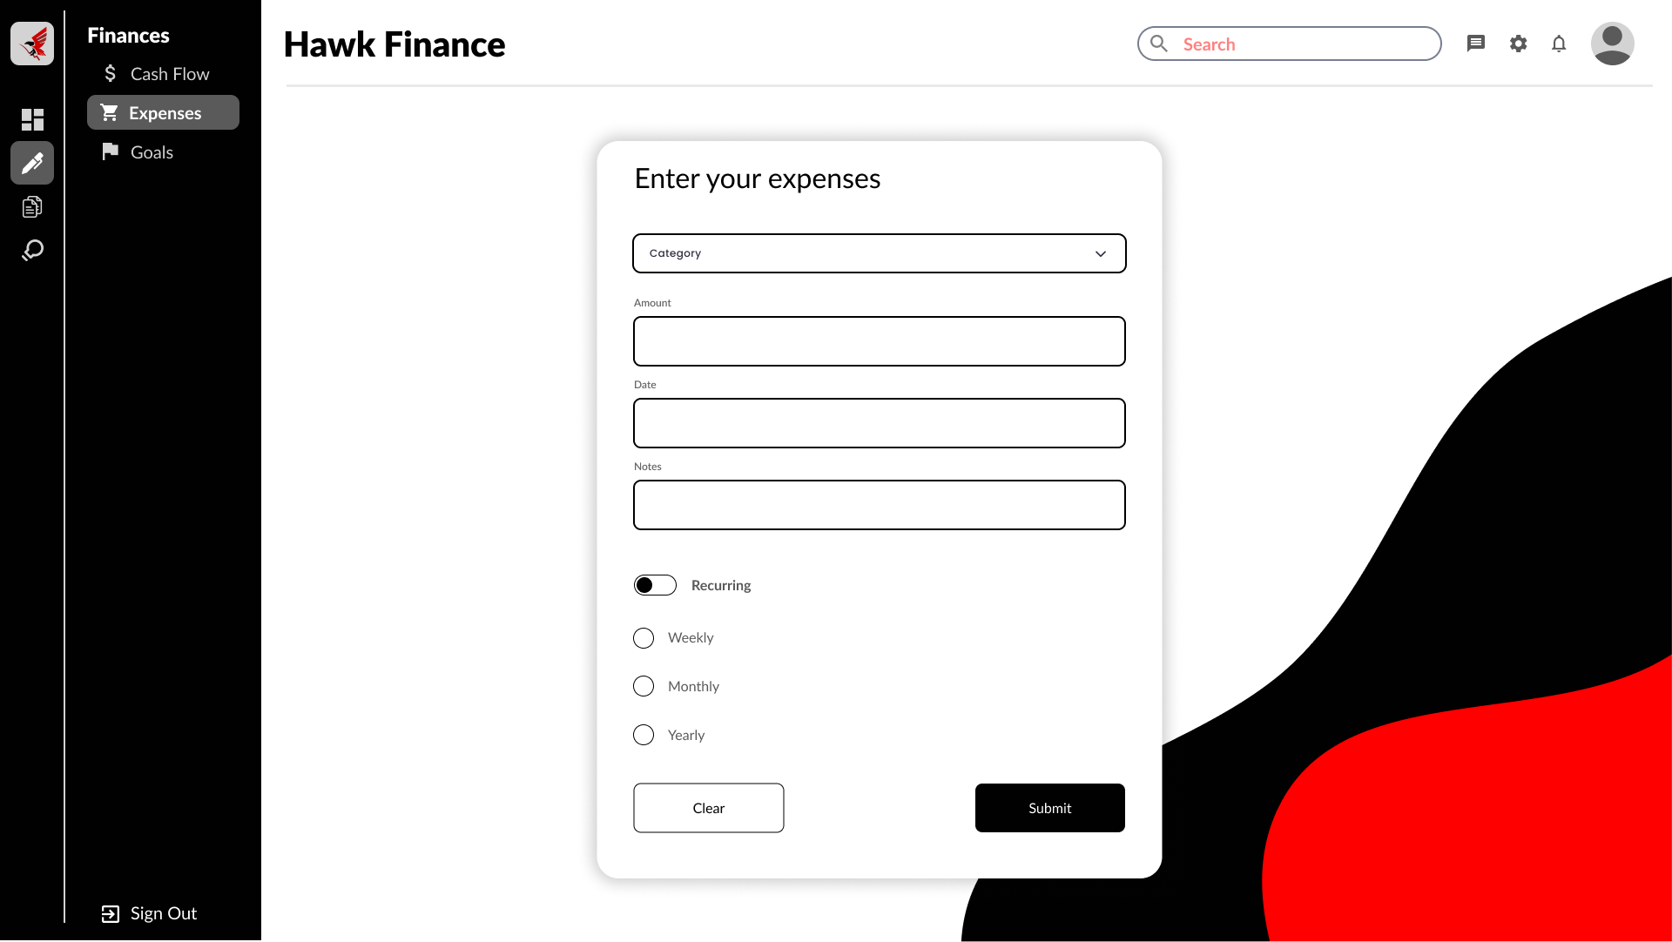

Inputting Goals

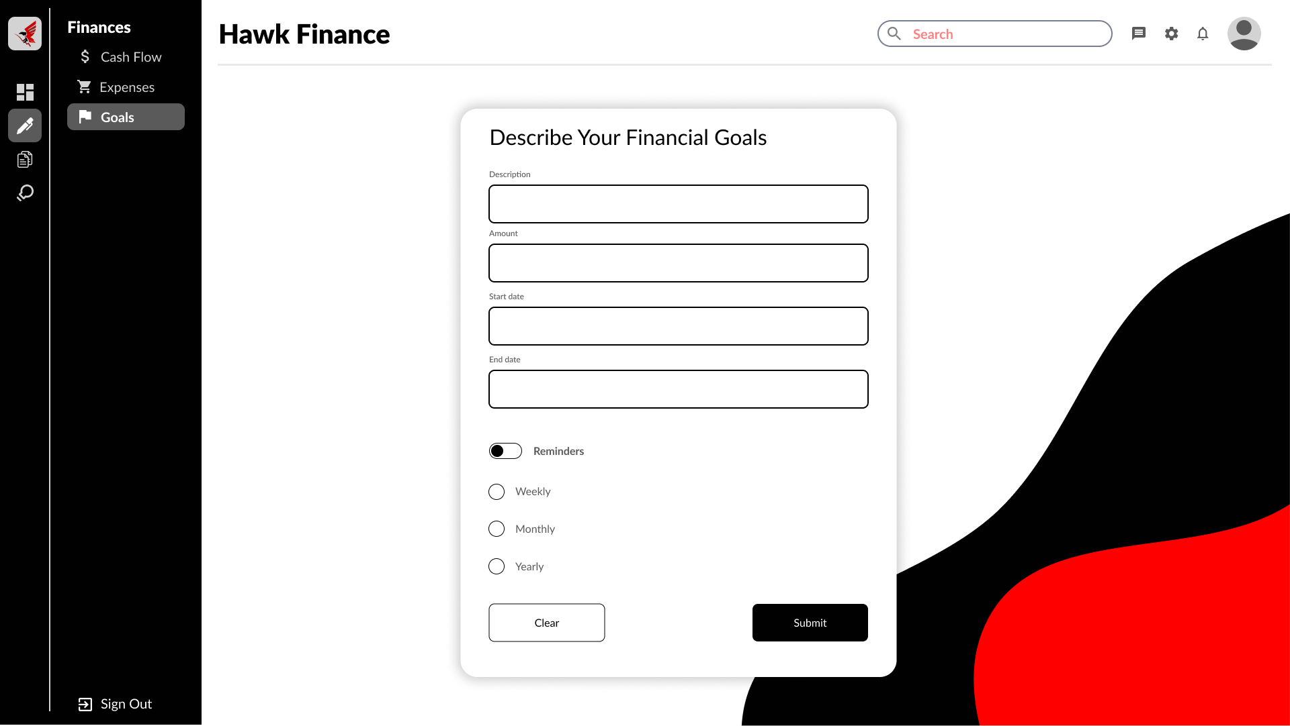

Transaction Summary

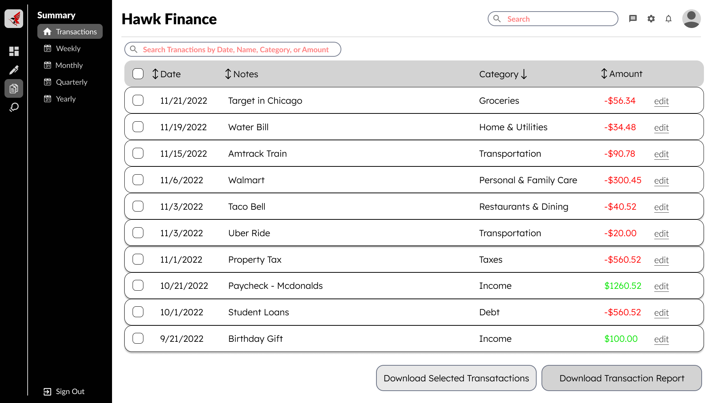

Weekly Transaction Summary

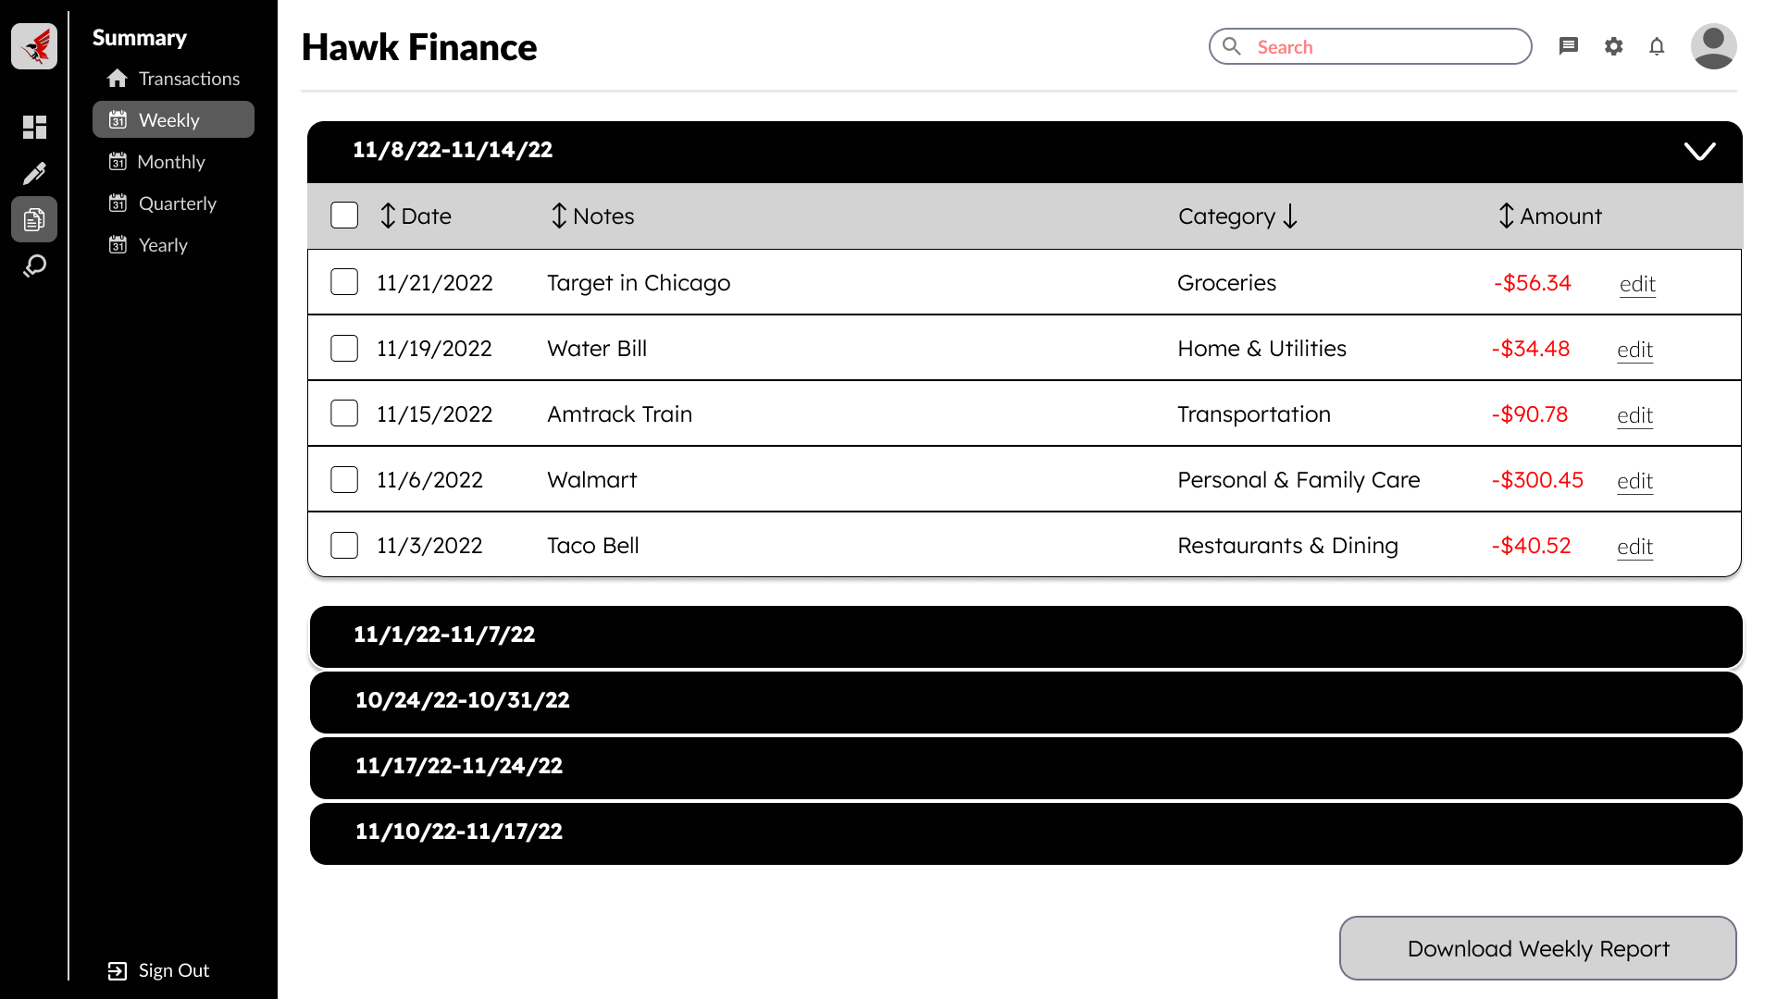

Monthly Transaction Summary

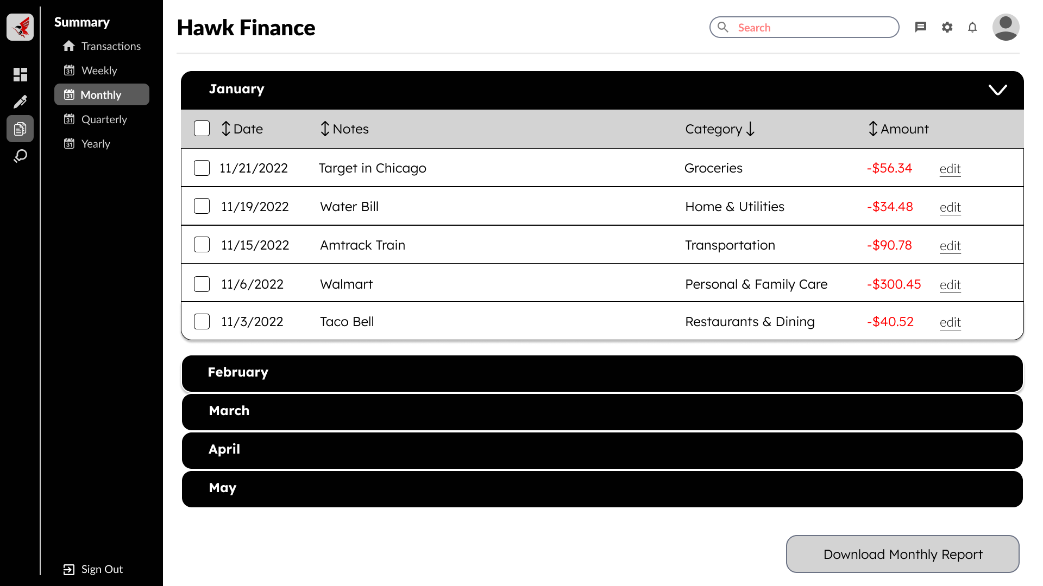

Quarterly Transaction Summary

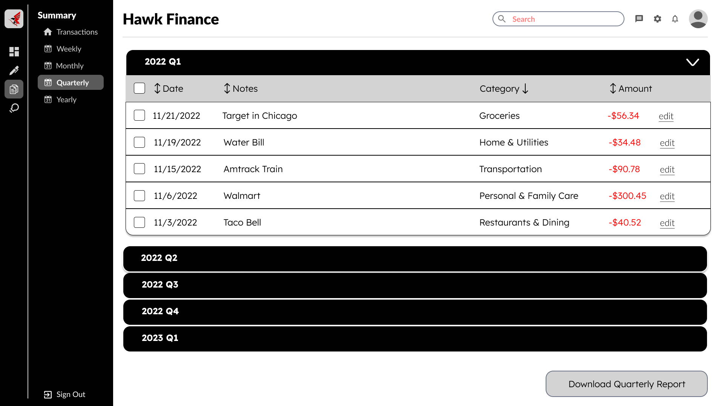

Yearly Transaction Summary

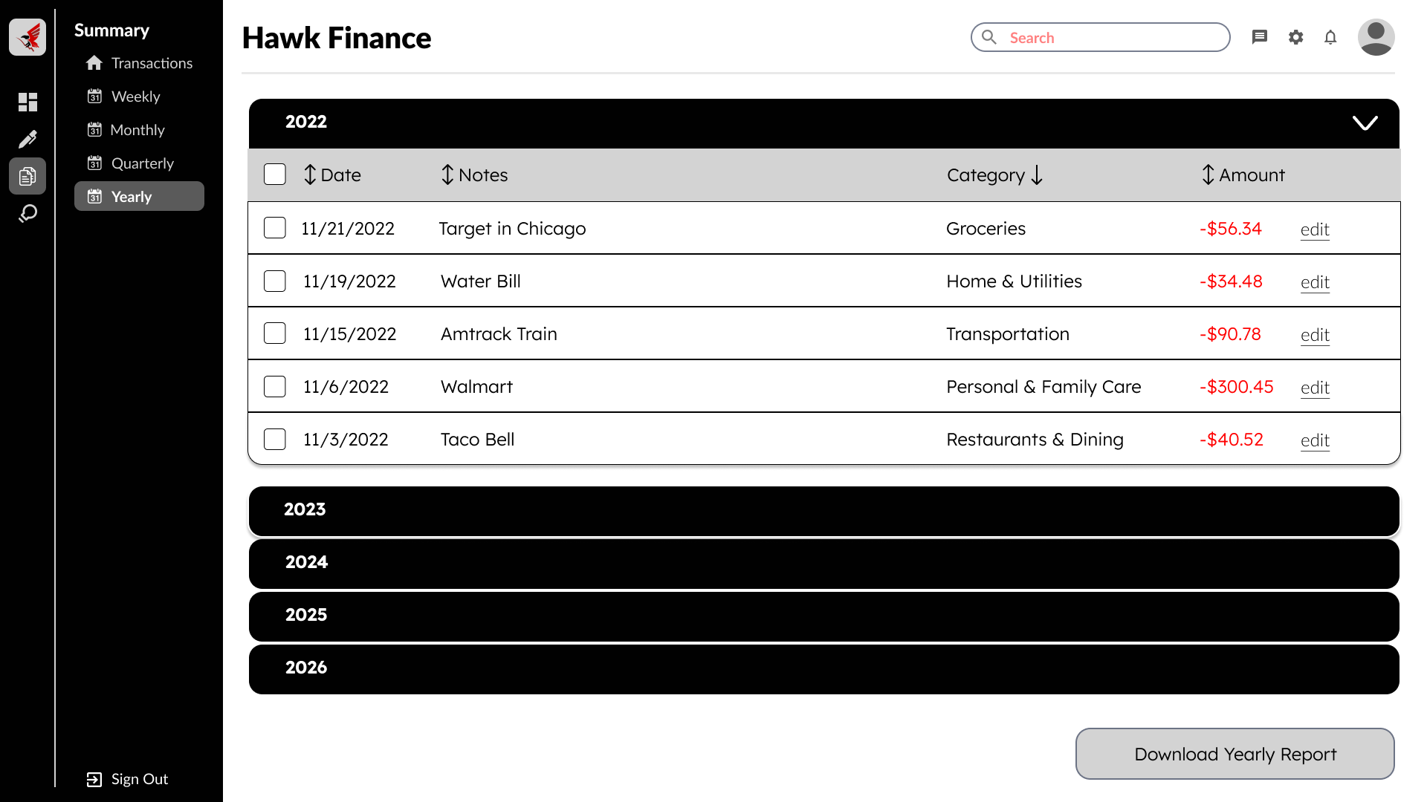

Income vs Expenses

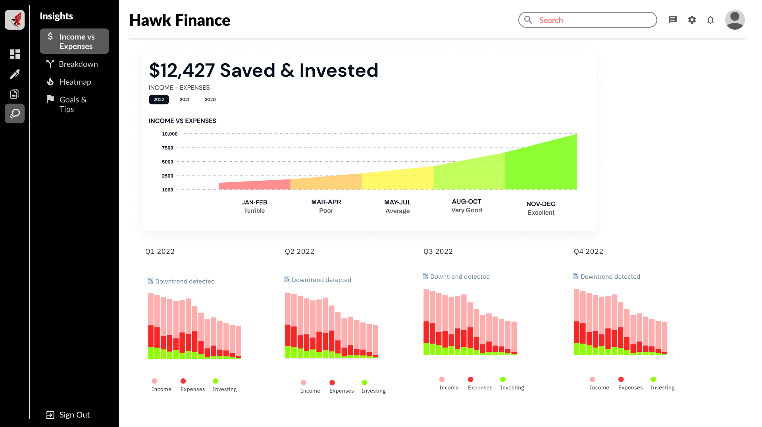

Breakdown

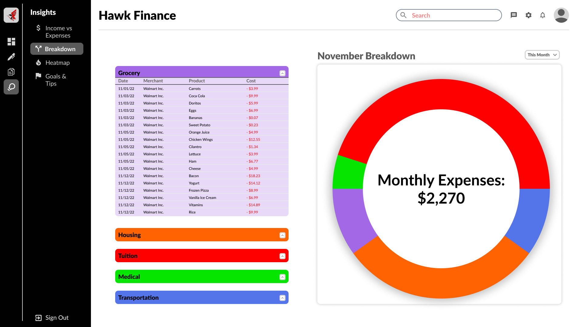

Heat Map

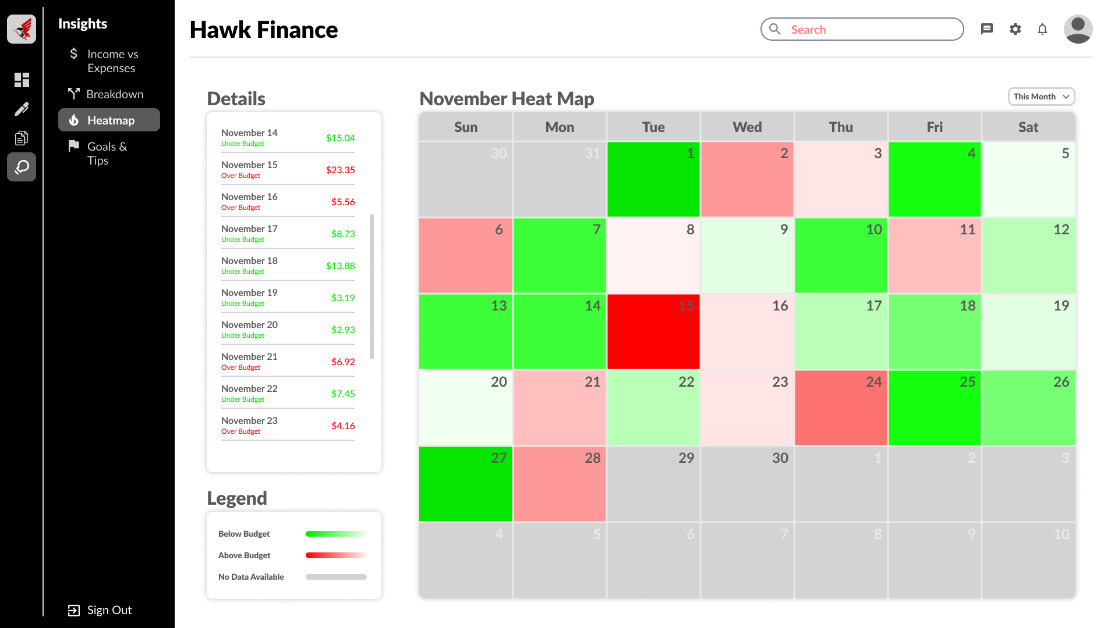

Goals & Tips

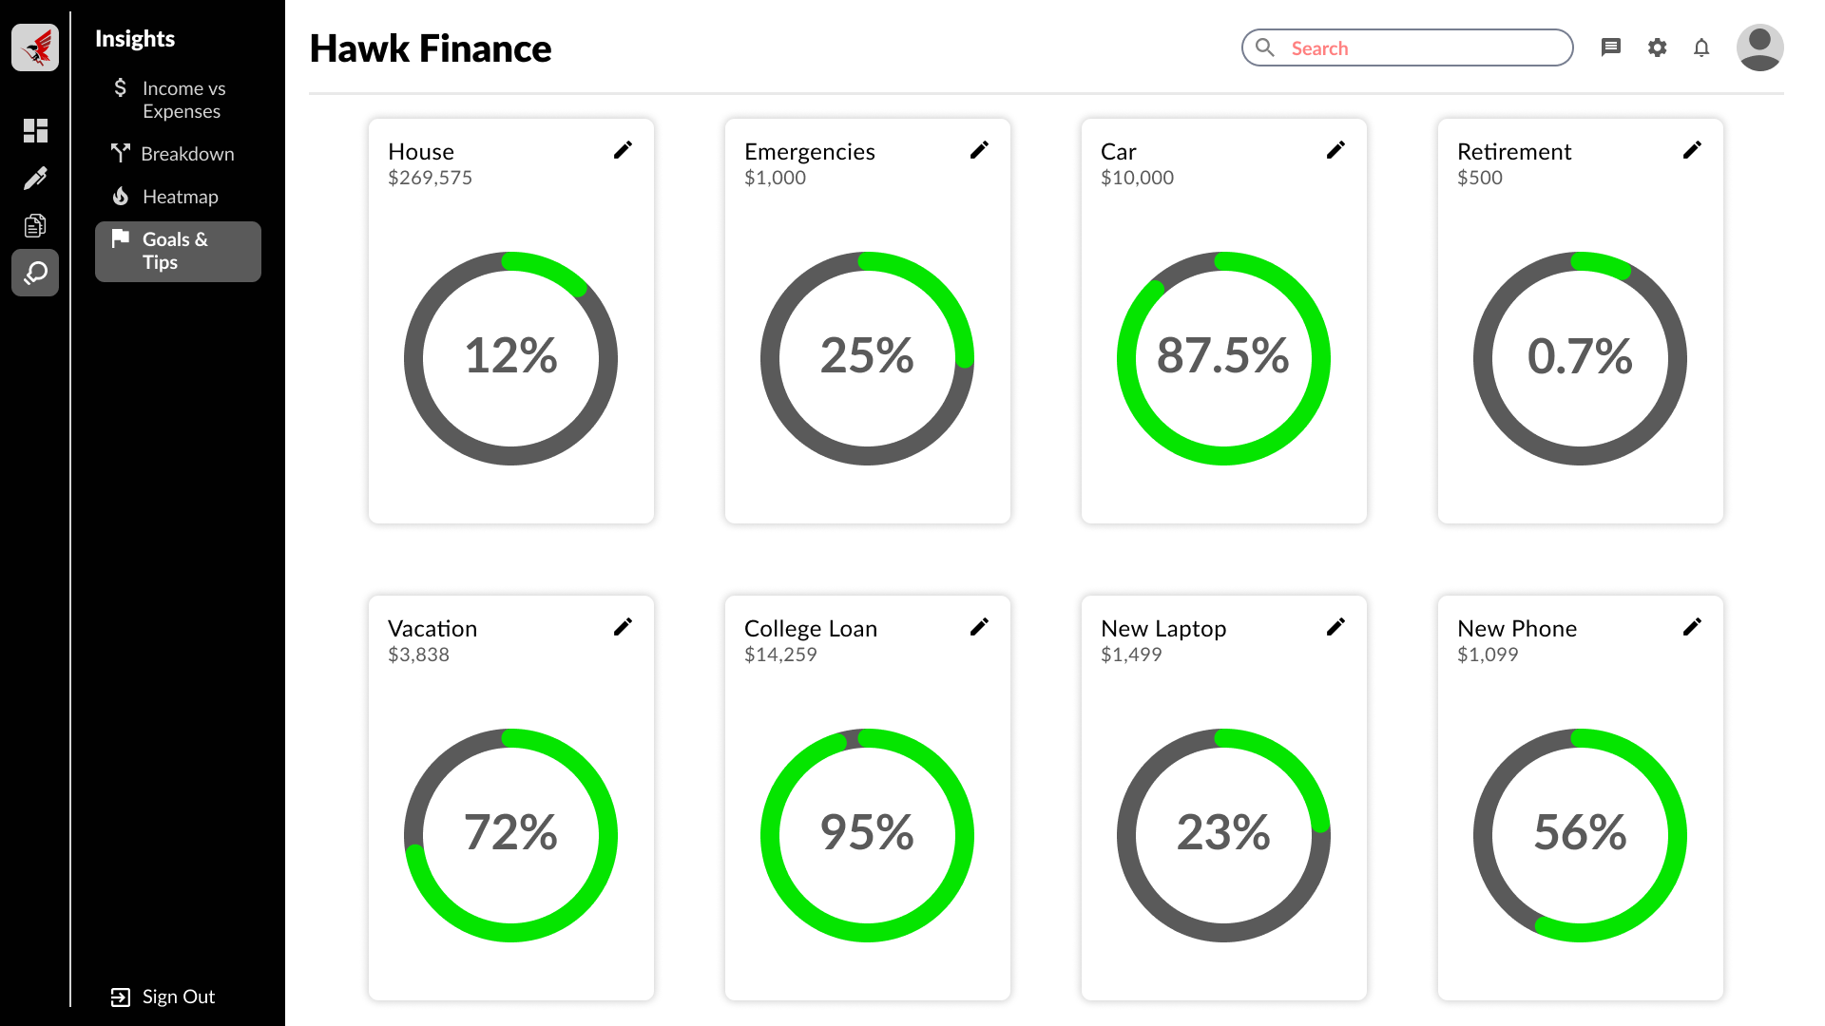

Sign Up Page

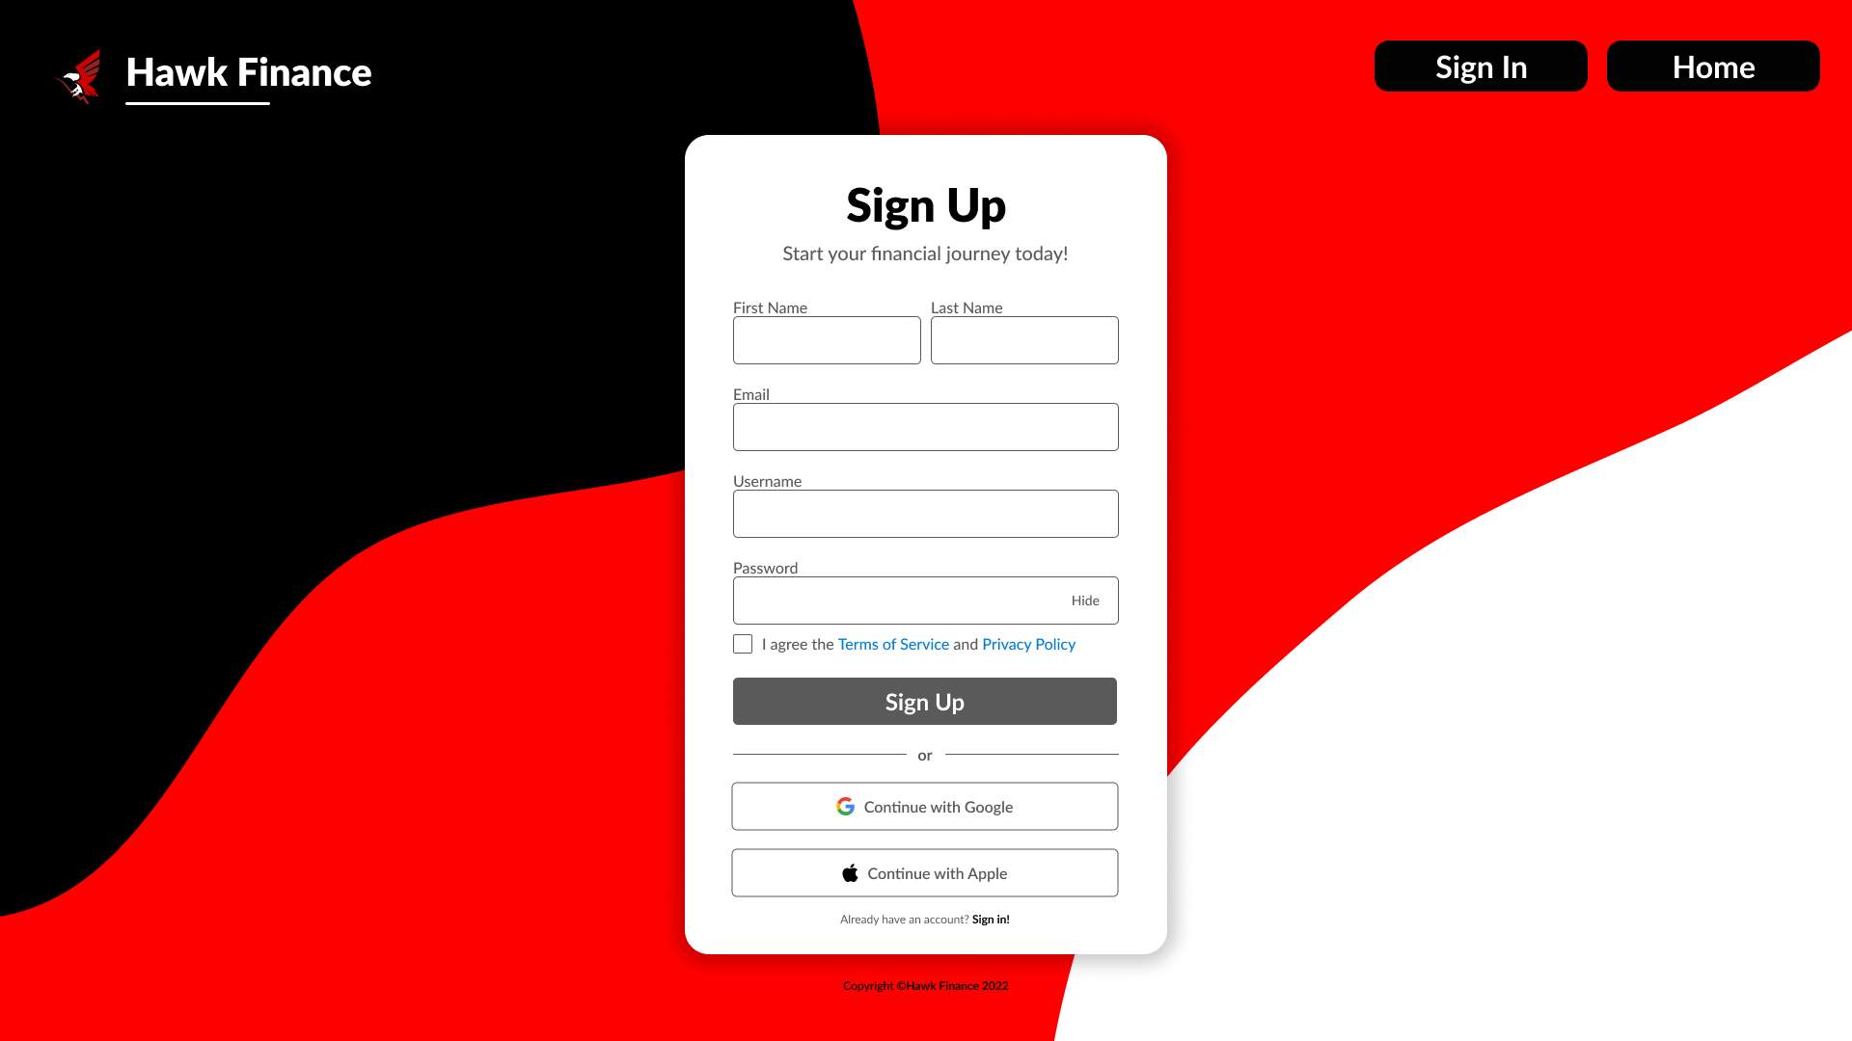

Sign In Page

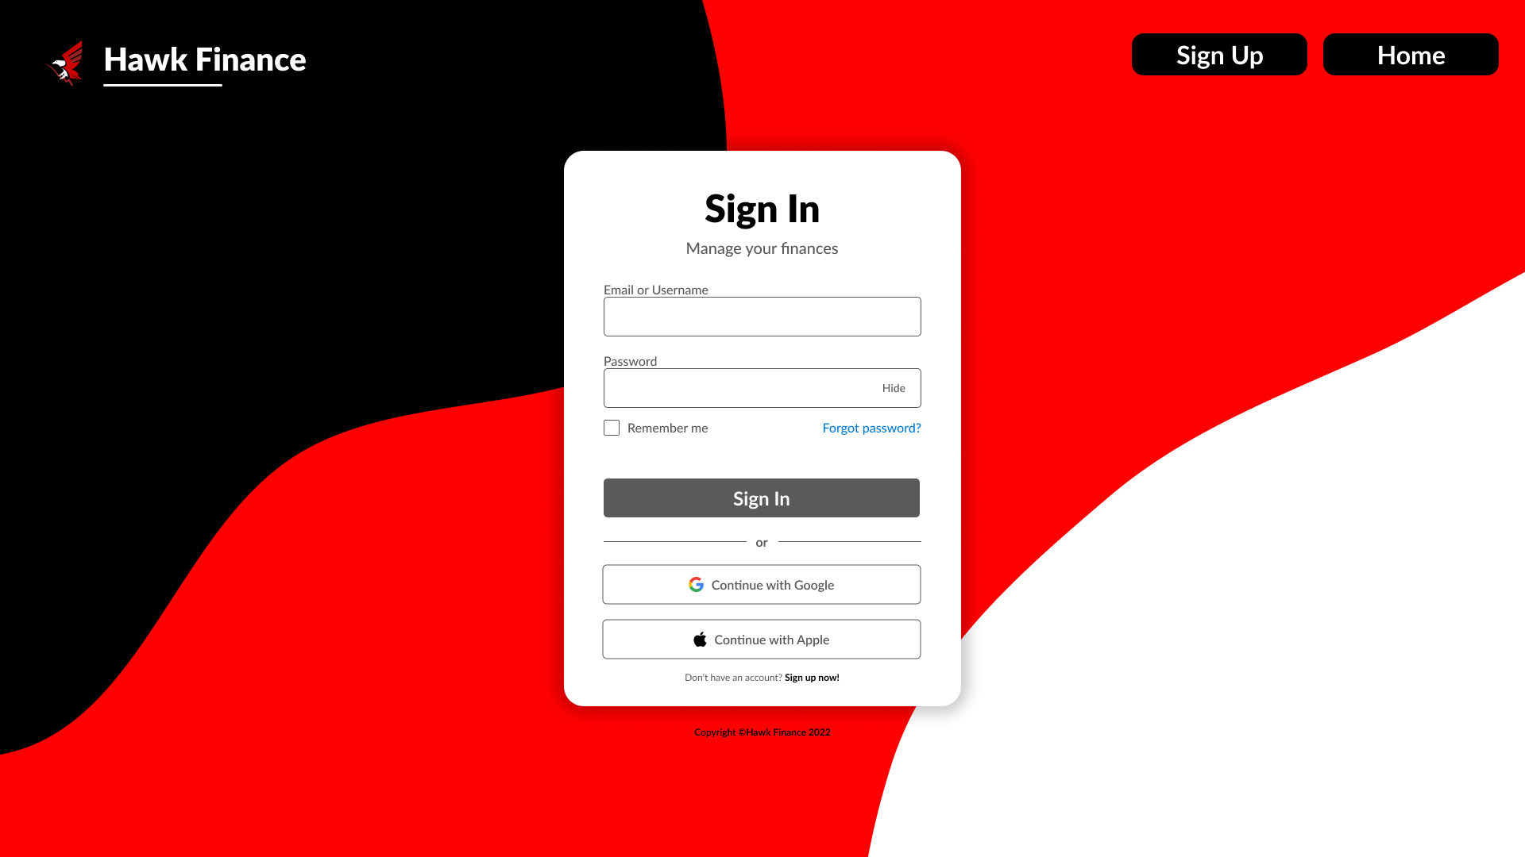

Forgot Password Page

